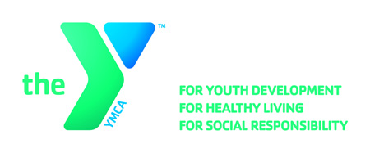

**OPEN POSITION ANNOUNCEMENT**

**Position:** **Barn Assistant (PT)**

Two (2) positions Available

**Locations:** Minikani Equestrian Center(867 Amy Belle Lane, Hubertus, WI 53033)

**Hours:** Vary based on Date – Mornings and Afternoons/Evening

**Reports to:** Equestrian Director

**Wage Range:** $7.50 - $8.50 per hour (Based on experience)

**Major Responsibilities:**

* General daily care of horses including but not limited to feeding; mucking stalls; daily check on horses
* Daily care of facility

**Qualifications:**

* Must be at least 16 years old
* Horse knowledge and handling experience
* CPR and First Aid certification required; Lifeguard certification preferred
* Good communication skills
* Good customer service skills
* Available to work a minimum of 1 weekend day
* Preferably have driver’s license; reliable transportation a must

**Benefits:**

Excellent benefits include free membership and discounted YMCA child care and other programs. The incumbent will exhibit the core values of caring, honesty, respect, and responsibility in all aspects of their work with the YMCA

**Deadline:**  **January 13, 2017**

**Apply Online:** [**https://apply.ymcamke.org**](https://wfa.kronostm.com/index.jsp?locale=en_US&APPLICATIONNAME=YMCAofMetropolitanMilwaukeeKTMDReqExt)