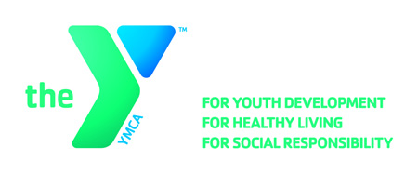

**OPEN POSITION ANNOUNCEMENT**

**Position:** **Member Service Attendant – Kid Zone (PT)**

**Location(s):** Rite-Hite YMCA

**Hours:** Varying Hours Mornings, Evenings and Weekends

**Reports to:** Membership Director

**Wage Range:**  $7.25 - $8.80 per hour based on experience

**Major Responsibilities:**

* Responsible for performing all duties required in caring for children ages six weeks through 12 years.
* Supervise, interact and play with children to ensure their safety and happiness through the implementation of innovative activities.
* Communicate effectively with children and adults while demonstrating patience and a mature, professional attitude. Greet all adults and children entering Kid Zone with a smile and personal greeting. Employ effective customer service techniques. Provide parents with information regarding their child’s experience.
* Maintain accurate records including check-in times, payments, etc.
* Attend staff meetings and training sessions as scheduled.
* Responsible for other duties and projects as necessary to achieve goals and priorities of the Association. Serve as a highly-visible role model and ambassador. Communicate and interpret the Association’s mission, purpose and goals to volunteers, parents, and program participants.

**Skills and Qualifications:**

* Must be at least 16 years of age.
* Must have the ability to lift at least 40 pounds and stand and hold up to 20 pounds.
* Must be a responsible, enthusiastic, and approachable person who is courteous, friendly and calm in providing quality member service in a fast-paced environment.
* Practical knowledge of preschool age children and infants.
* Ability to interact with children of all ages, at the child’s level, including bending and sitting on the floor.
* Ability to deal with a variety of members, staff and volunteers through effective written and verbal communication.
* Must be able to work in cooperation with a team and take input from multiple sources.

**Benefits:**

Excellent benefits include a free membership and discounted YMCA child care and other programs. The incumbent will exhibit the core values of caring, honesty, respect, and responsibility in all aspects of their work with the YMCA.

**Deadline: January 19, 2018**

**Apply Online:** [**https://apply.ymcamke.org**](https://wfa.kronostm.com/index.jsp?locale=en_US&APPLICATIONNAME=YMCAofMetropolitanMilwaukeeKTMDReqExt)