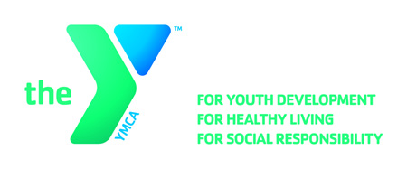

**OPEN POSITION ANNOUNCEMENT**

**Position:** **Program Instructor – Pre-School Enrichment (PT)**

**Locations:** Rite-Hite YMCA (9250 N. Green Bay Rd., Brown Deer, WI)

**Reports to:** Program Director

**Wage Range:** $7.35- $7.85 per hour (based on experience)

**Hours:** Weekday Mornings/Occasional Evenings & Weekends

**Major Responsibilities:**

* Responsible for planning and implementing sound preschool programs founded in best practice, which will foster the child’s social, spiritual, physical and mental growth.
* Interact with children. May include activities such as getting down onto the floor to work with the children, running, jumping and lifting set up equipment.
* Good oral and written communication skills with children and adults, which include patience and a mature professional attitude.
* Good decision-making skills, ability to adapt the program as the situation requires.
* Uphold and exemplify the principles of the YMCA Member Service Program.

**Qualifications:**

* The candidate must be at least 16 years old
* Experience in supervision of youth is preferred, will work with youth ages 3-12 years old
* Must possess skills in human relations, planning, promotion, and youth supervision
* Creativity, initiative, flexibility, eagerness to seek out and involve others and genuine concern for today’s youth are essential
* This position requires certification in CPR/AED Pro, O2, First Aid and the competency to respond to emergency situations. Certifications are required within 60 days of hire. Training opportunities will be available and provided by the YMCA

**Benefits:**

Excellent benefits include a free membership and discounted YMCA child care and other programs. The incumbent will exhibit the core values of caring, honesty, respect, and responsibility in all aspects of their work with the YMCA.

**Deadline: January 19, 2018**

**Apply Online:** [**https://apply.ymcamke.org**](https://wfa.kronostm.com/index.jsp?locale=en_US&APPLICATIONNAME=YMCAofMetropolitanMilwaukeeKTMDReqExt)