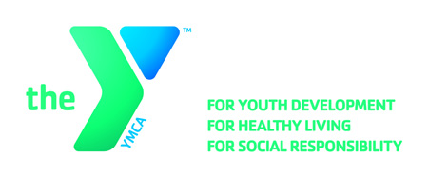

**OPEN POSITION ANNOUNCEMENT**

**Position:** **Wellness Center Attendant (Part-Time)**

**Locations:** Downtown YMCA

**Hours:** 8-12 Varied Hours

**Reports to:** Fitness Director

**Wage:** $7.60 - $9.50 per hour (based on experience)

**Major Responsibilities:**

* Creating a welcoming atmosphere for all which results in relationship building with prospective members, increased enrollments and retention.
* Assisting new members in developing fitness plans based on their personal goals and wellness guidelines.
* Providing weekly feedback and encouragement to all assigned wellness program participants in the form of face-to-face, electronic messaging, phone calls and/or mailings.
* Instructing wellness program participants on safe and effective exercise techniques, including, but not limited to, warm-up and stretching progression, aerobic conditioning, strength training, proper use of equipment and workout progression.

**Qualifications:**

* Ability to develop on-going relationships with members and participants, leading to enhanced member retention and program participation
* Able to effectively communicate with a wide variety of members, staff and volunteers in a wide range of settings and situations.
* College degree in a fitness/wellness related field is preferred.
* Must be CPR & First Aid certified within 2 months of hire; training provided.

**Benefits:**

Excellent benefits include a free individual membership, discounted YMCA child care and other programs. The incumbent will exhibit the core values of caring, honesty, respect, and responsibility in all aspects of their work with the YMCA

**Deadline**: **January 26, 2018**

**Apply Online:** [**https://apply.ymcamke.org**](https://wfa.kronostm.com/index.jsp?locale=en_US&APPLICATIONNAME=YMCAofMetropolitanMilwaukeeKTMDReqExt)